If you have any technical difficulties with any of your end of year spreadsheets please email Lynn.Scarsbrook@britishcouncil.org.my and cc your project manager.

KPI 1
On each teacher’s worksheet on the Mentor Input Log (tabs for teachers 1 -10), add any sessions and field visits that you expect to have between now and the end of the project in the final ‘Predicted/Planned Hours’ column. Please make your calculations clear.

Make sure that your name, sub-cluster and state appear at the top of the ‘Automated Summary’ worksheet page. This should automatically appear when you have entered the information on the Data tab.

Count the number of Level 1 Bonus Teachers you’ve worked with this year from your ‘Bonus Tchr’ tab on the Mentor Input Log. The total number of hours should be on the ‘Bonus Stats’ tab, you may need to refresh the pivot table. If none, for data collection purposes please enter 0 on the self-certification document.

The rest of data that you’ll need for the KPI 1 self-declaration form is from the ‘Automated summary tab’ (pink column below). Please keep to the ‘Y’ or ‘N’ formatting for the first row as this data will be copied into a project-wide database. Please note, the Ministry of Education recently re-calculated the KPI hours in light of the project ending in September. The KPI 1 target for 2015 is 55 not 75 hours, this means any teacher achieving more than 55 hours has achieved their target.

Example: please use totals from this column on your log:

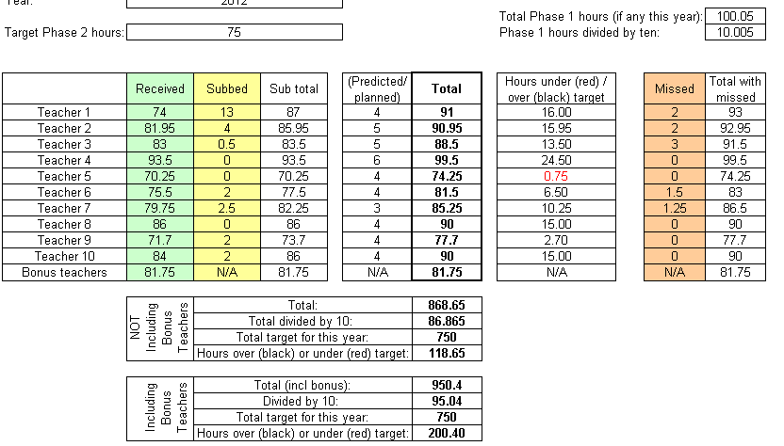

KPI 2: RoA and Self-Certification
The self-certification is fairly self-explanatory. Please note that the question asking whether there has been any improvement is very broad and covers any element of teaching and learning.

‘Baseline rating’ refers to the first time you assessed the mentee at the start of their time on the project. ‘Final rating’ refers to the end of project assessment in August 2015. As this is measured over the lifetime of the project you will need to include data from all teachers who were on the project for more than three months, not just your current 10 project teachers.

Please complete the final assessment columns on your RoA spreadsheet. This can be based on mentor judgement. Note the number of months that have passed between start (baseline) and end of project (final) assessments.

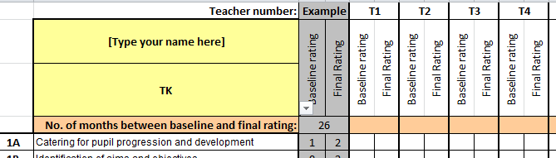

Before you submit your form, please check:
- You have typed your name in the first yellow box
- You have selected the initials of your PM from the dropdown menu in the second yellow box (This information is used to sort the project data by State for reporting purposes so please let Lynn know of any difficulties.)
- You have completed the number of months between assessments in the pink/brown(?) box for each teacher.

KPI 3: CEF and Self-Certification
The self-assessment form should be fairly self-explanatory. Please note that the question asking whether there has been any improvement is very broad and it is possible for a teacher to have made improvements over a short time even if this is not reflected by a change in grade.

‘Baseline rating’ refers to the first time you assessed the mentee at the start of their time on the project. ‘Final rating’ refers to the end of project assessment in August 2015. As this is measured over the lifetime of the project you will need to include data from all teachers who were on the project for more than three months, not just your current 10 project teachers.

Complete the final assessment on your CEF spreadsheet. This can be based on mentor judgement. Note the number of months that have passed between baseline and final assessments. Please note: Your data will be transferred to a master spreadsheet it is important you record your state, district and name on each row of the spreadsheet, you can of course simply copy and paste the data into each row.

Please also send 1 example of a completed English Proficiency Annual Development Plan for 1 teacher. This can be a scan of a handwritten document.

KPI 4: resources and Self-Certification:
KPI 4 is not measured per mentor or per teacher but rather is monitored across the project. Project managers will each create a Word document of the best photos from their zone so please send 3 pictures through. Don’t worry about adding teacher, school or cluster names but please do rename the file (as with all the KPI documents you send) so that it has your name with a short caption for easy filing. For example:
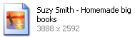

Please note if you are sending images with people who are visible please ensure you have the appropriate consent to share these photos.

Sending images
We know sending attachments by email isn’t always an easy process.
Where internet connection is poor, emails with multiple attachments will be frustratingly slow to send. You may wish to send images one at a time if this affects you. Please note: the British Council limit for emails is 10MB (aim for 8MB max to be safe).

Alternatively, you can compress images in Microsoft Office Picture Manager on your laptop.
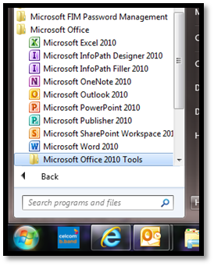
To find the program:

1. Click the start button in the bottom right hand corner of the screen and click on all programs.

2. Select ‘Microsoft Office’ and then select ‘Microsoft Office 2010 tools’. You can now open ‘Microsoft Office Picture Manager’

3. Open your image and click on  in the tool bar. This opens a menu on the right hand side of the screen.
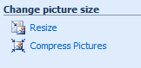
4. The last option in the list is compressing images. Click

5. Select compress for: documents and click OK.

6. You can then use the ‘file’, ‘save as’ process to change your file name ready to attach your image.

If all else fails, put the documents in a word document as images can be extracted later (this also reduces file size for sending). Please make sure if you do this you clearly label each image within the word document so that can easily and accurately be saved at source.
KPI 5 Pupil assessment and Self-Certification:
Please work with your teachers to collect a final assessment of pupil achievement and complete the spreadsheet noting the number of months between assessments.

Please note that the question asking whether there has been any improvement is very broad and covers any element of English Language oracy and literacy.

On the self-certification form please note reasons why pupils made significantly higher or lower progress than their peers. These can be general but supporting evidence may be requested at a later date.

